Tender Notice
DAV IPS Sector 8B, Bokaro DAV IPS Sector 9E, Bokaro DAV IPS Sector 2C, Bokaro DAV IPS Sector 12E, Bokaro

Tender No.: PRINTING/01 Date: 20/8/2025

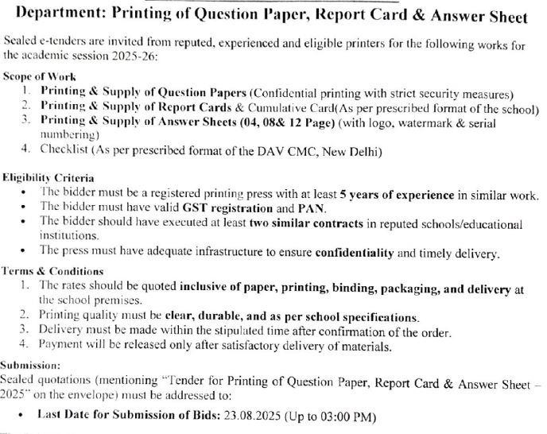

Submission Details:
- Last Date for Submission of Tender: 25/8/2025
- Opening of Tender: 20/8/2025 and at 10 a.m
- Place of Submission: DAV IPS Sector 8B, Bokaro
- Contact Person: Mr Dilip Kumar
The quotation should be also be sent via post/by hand/by mail id davbsl8b@gmail.com .

Note: Incomplete tenders or tenders received after the due date will be rejected. Bidders are advised to visit the school during working hours for assessment, if needed.
M Mallik Teacher I/C

