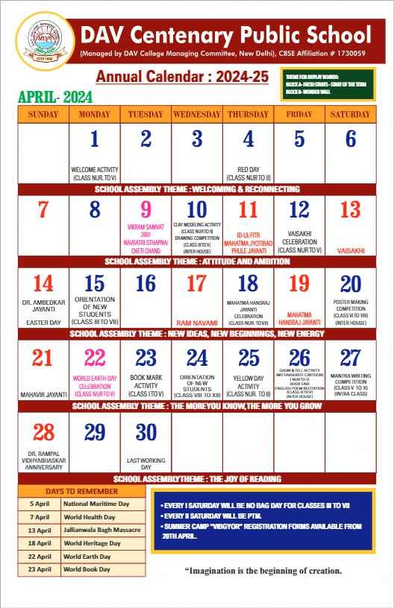
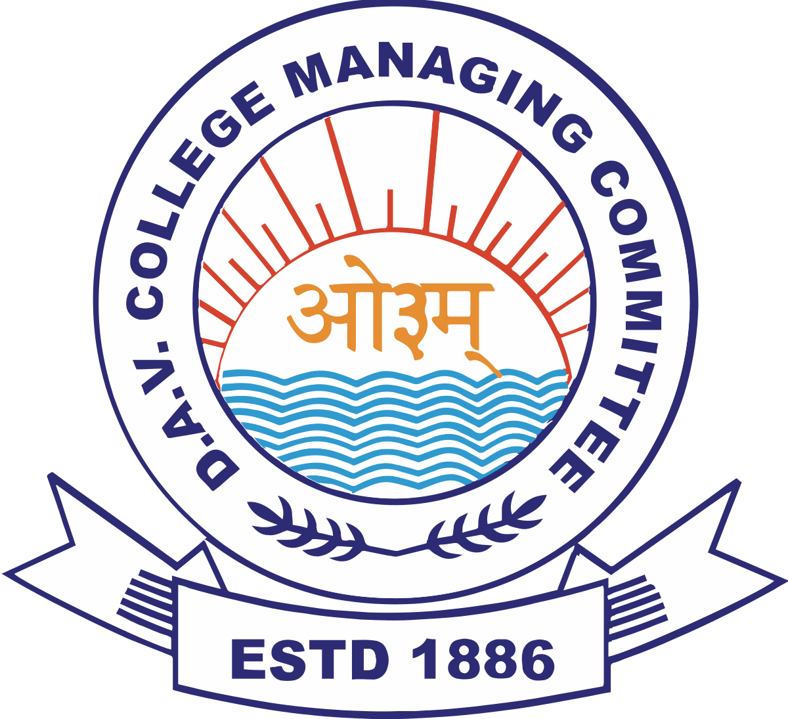
D.A.V. Public School, Behror
(Managed by DAV College Managing Committee, New Delhi), CBSE Affiliation #1730638

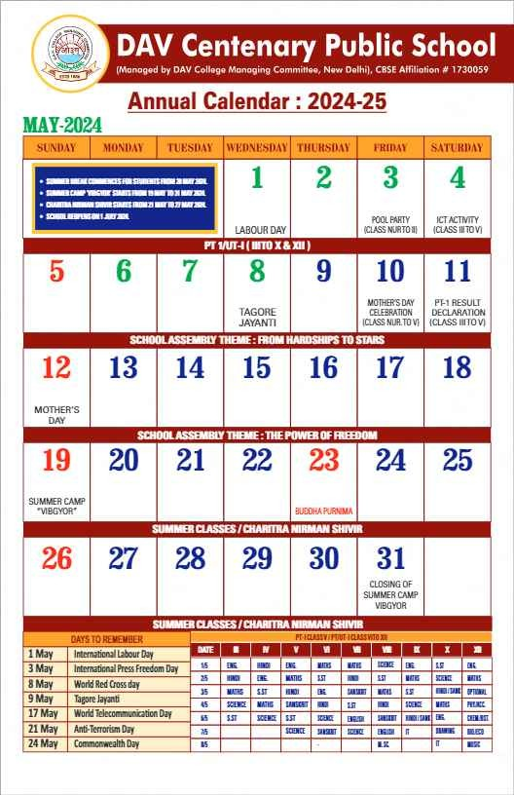
D.A.V. Public School, Behror
(Managed by DAV College Managing Committee, New Delhi), CBSE Affiliation #1730638

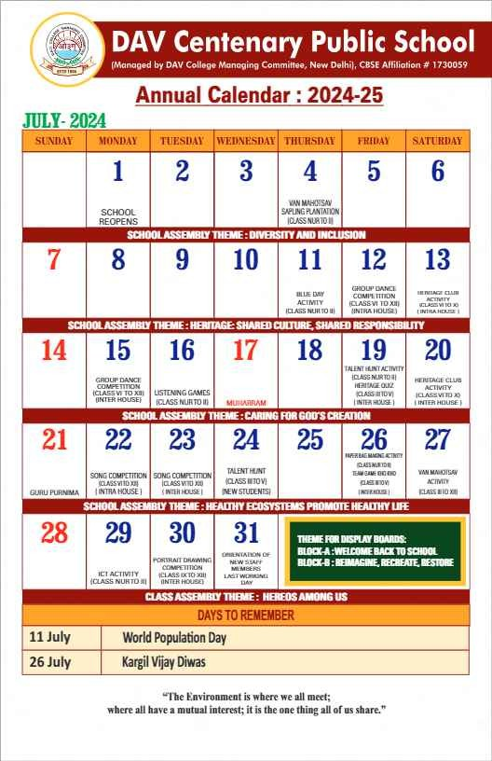
D.A.V. Public School, Behror
(Managed by DAV College Managing Committee, New Delhi), CBSE Affiliation #1730638

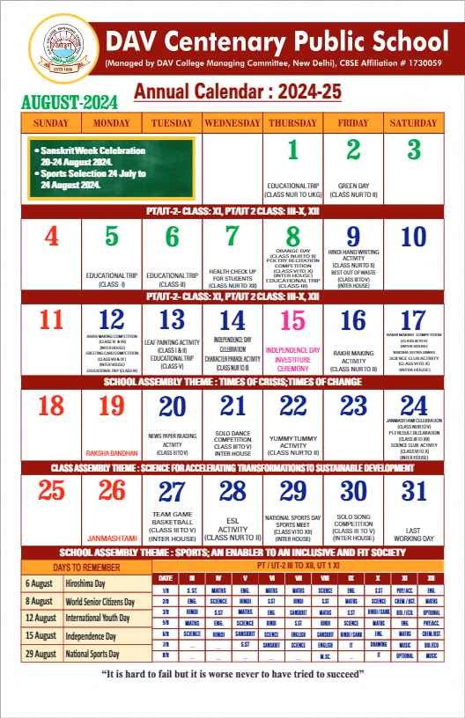
D.A.V. Public School, Behror
(Managed by DAV College Managing Committee, New Delhi), CBSE Affiliation #1730638

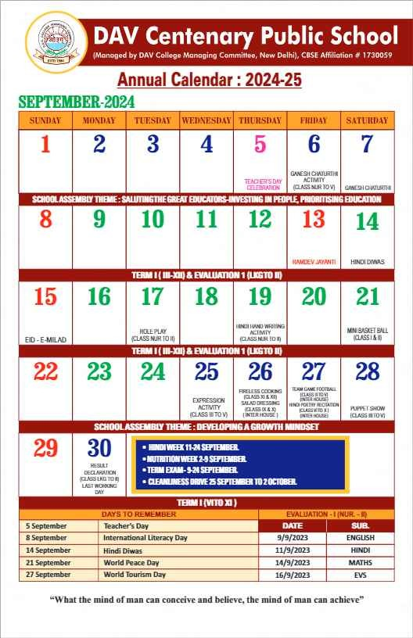
D.A.V. Public School, Behror
(Managed by DAV College Managing Committee, New Delhi), CBSE Affiliation #1730638

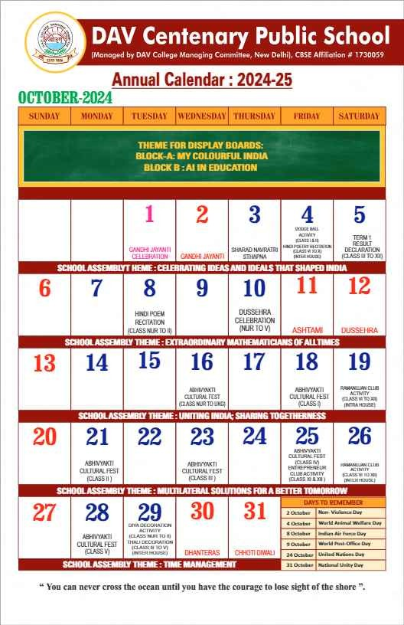
D.A.V. Public School, Behror
(Managed by DAV College Managing Committee, New Delhi), CBSE Affiliation #1730638

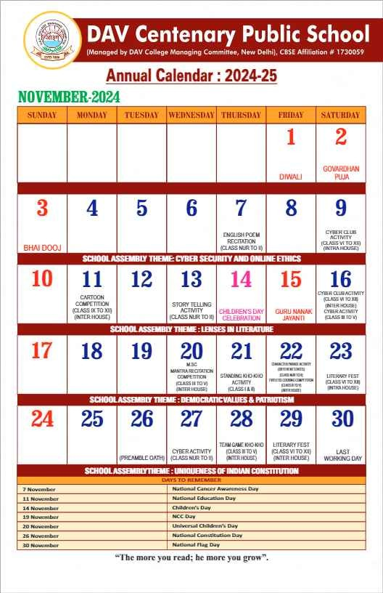
D.A.V. Public School, Behror
(Managed by DAV College Managing Committee, New Delhi), CBSE Affiliation #1730638

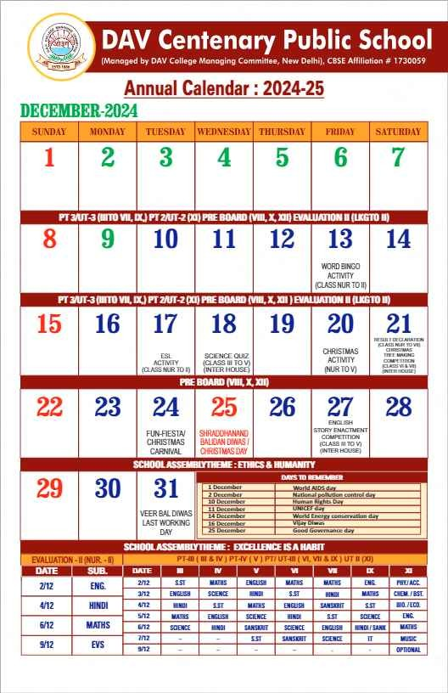
D.A.V. Public School, Behror
(Managed by DAV College Managing Committee, New Delhi), CBSE Affiliation #1730638

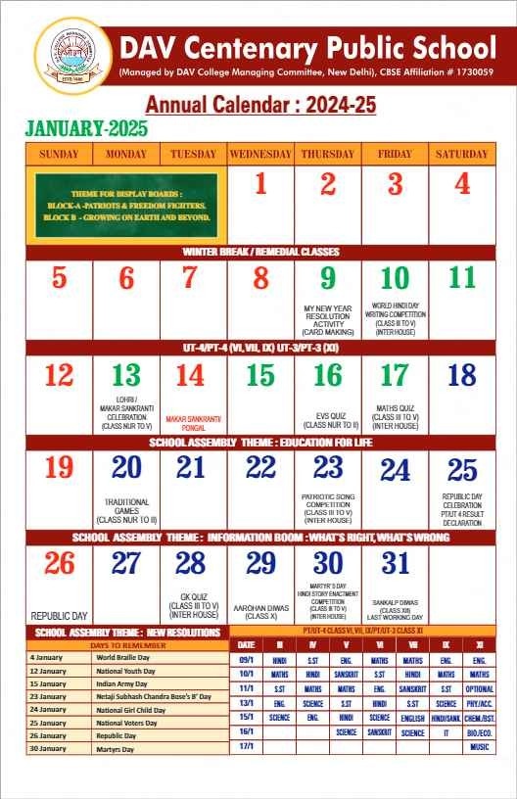
D.A.V. Public School, Behror
(Managed by DAV College Managing Committee, New Delhi), CBSE Affiliation #1730638

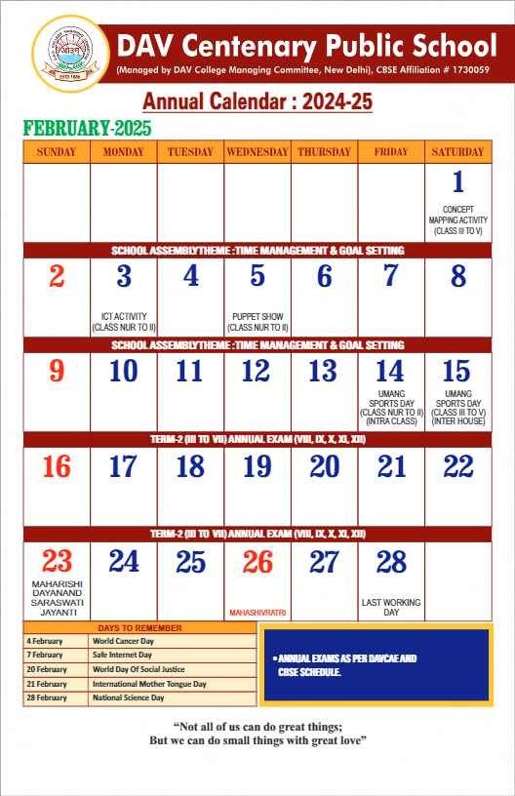
D.A.V. Public School, Behror
(Managed by DAV College Managing Committee, New Delhi), CBSE Affiliation #1730638

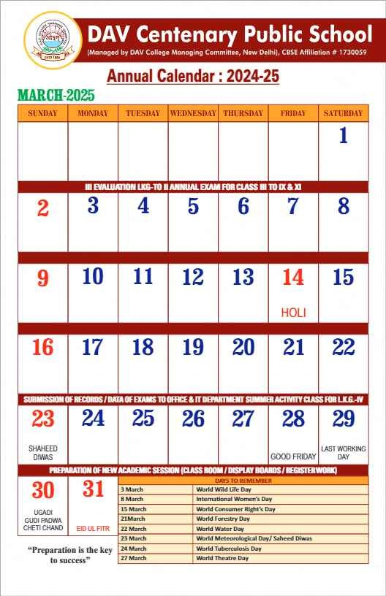
D.A.V. Public School, Behror
(Managed by DAV College Managing Committee, New Delhi), CBSE Affiliation #1730638

