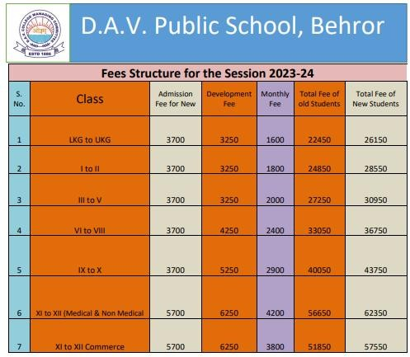
Fees Structure For the Session 2024-25

